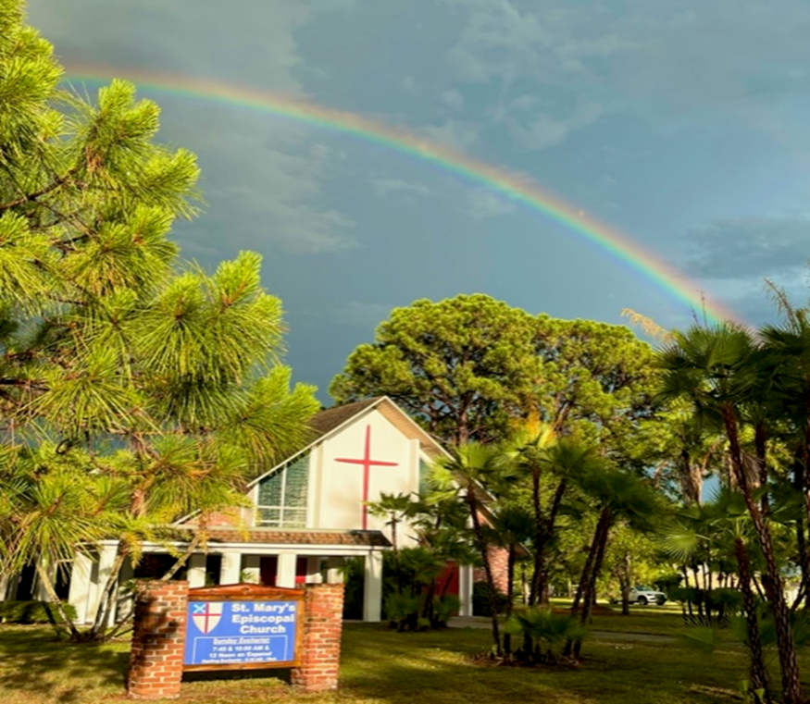

**Photo by Susan Hunt**

1010 24th Avenue West, Palmetto, FL 34221

941-722-5292

Email – [stmaryspalmetto@verizon.net](mailto:stmaryspalmetto@verizon.net)

Website – stmaryspalmetto.com

**Pentecost 17**

**September 15, 2024**

**PARISH STAFF**

**The Rev. Glen Graczyk, Rector** [frgleng@gmail.com](mailto:frgleng@gmail.com) (727) 432-4014

**The Rev. William de la Torre, Hispanic Ministry (**813) 802-8617

**Rev. Cheri Ford, Assisting Priest** (941) 981-3195)

**Music Minister: Joyce Ives** (603) 236-1939

**Admin. Asst. Elisa Hughes** [stmaryspalmetto@verizon.net](mailto:stmaryspalmetto@verizon.net) (813) 394-0032

**ST. MARY’S VESTRY**

**Senior Warden – Frank Grondahl** [ffgskg@msn.com](mailto:ffgskg@msn.com) **(**941) 900-1009

**Junior Warden** **– Bill Cooley** [dcool12839@gmail.com](mailto:dcool12839@gmail.com) (518) 796-2352, (518) 791-2774

**Treasurer**- **Lorraine Wood** [ljhwood53@gmail.com](mailto:ljhwood53@gmail.com) (941) 447-3570

**Beverly Hunt** [Huntb104@gmail.com](mailto:Huntb104@gmail.com) (941) 228-1888

**Nancy Valenti** [nancyval@hotmail.com](mailto:nancyval@hotmail.com) (941) 729-1824

**Peggy Brogan** [pegbrogan48@gmail.com](mailto:pegbrogan48@gmail.com) **(**941) 744-6429

**Lynda Priepot** [lyndajpriepot@yahoo.com](mailto:lyndajpriepot@yahoo.com) (941) 504-2505

All music printed in bulletin is under One Lic

**10:00 – Prelude: *Bagatelle*** – Ludwig van Beethoven

**10:00 - Call to Worship: *Lord be glorified***

*In my life, Lord, be glorified, be glorified.*

*In my life, Lord, be glorified today.*

*In your church, Lord, be glorified, be glorified.*

*In your church, Lord, be glorified today.*

**10:00 - Processional Hymn: *Lift high the cross*** *- #473*

**Greeting:**

**C:** Blessed be God: Father, Son, and Holy Spirit.

**P:** And blessed be his reign, now and forever. Amen

**Hymn of Praise:** ***The Gloria***

**7:45 -**– Page 356 **BCP**

**10:00** – **Gloria** - Blue music insert

**Collect of the day:**

O God, because without you we are not able to please you, mercifully grant that your Holy Spirit may in all things direct and rule our hearts; through Jesus Christ our Lord, who lives and reigns with you and the Holy Spirit, one God, now and forever.

**P**: Amen

**The Lessons**

*Sit*

**First Reading: *Isaiah* 50:4-9a**

**R:** The Word of the Lord.

***P:***  *Thanks be to God.*

**Psalm Response:** ***Psalm 116:1-8***

|  |
| --- |
| I love the LORD, because he has heard the voice of my supplication, *     because he has inclined his ear to me whenever I called upon him. |
| The cords of death entangled me; the grip of the grave took hold of me; *     I came to grief and sorrow. |
| Then I called upon the Name of the LORD: *     "O LORD, I pray you, save my life." |
| Gracious is the LORD and righteous; *     our God is full of compassion. |
| The LORD watches over the innocent; *     I was brought very low, and he helped me. |
| Turn again to your rest, O my soul, *     for the LORD has treated you well. |
| For you have rescued my life from death, *     my eyes from tears, and my feet from stumbling. |
| I will walk in the presence of the LORD *     in the land of the living. |

**Second Reading: *James* 3:1-12**

**R:** The Word of the Lord.

***P:*** *Thanks be to God.*

*Stand*

**10:00 - Gospel Hymn: *Take up your cross, the Savior said*** *- #675 vs. 1,2 & 3*

**C:**  My sisters and brothers a reading from the Holy Gospel of our Lord Jesus Christ according to Mark.

***P:***  *Glory to you, Lord Christ*

**Gospel: *Mark 8:27-38***

**C**: The Gospel of the Lord.

***P:*** *Praise to you Lord, Christ.*

**10:00 - Gospel Hymn:** #675 vs. 4 & 5

*Sit*

***Homily****:*

*Stand*

**Profession of Faith:*****Nicene Creed*** – Page 358 **BCP**

**Prayers of the People**:*Savior of us all, hear our prayer.*

**Confession of Sin:** Page 360 **BCP**

**Peace**

*Sit*

**Announcements:**

**Offertory Sentence:** Walk in love, as Christ loved us and gave himself for us, an  
offering and sacrifice to God.  Ephesians 5:2

**Offertory Hymn: *I have decided to follow Jesus*** *– Grey music insert*

**THE GREAT THANKSGIVING**

*Stand*

**Preface of the Lord’s Day**

**Sanctus: 7:45 *–*** P. 363 ***– BCP***

**10:00 *–*** ***Sanctus –*** *Blue music insert*

**Eucharistic Prayer B**

**Memorial Acclamation -**

**Great Amen -**

**The Lord’s Prayer:***Our Father . . .*

**Breaking of the Bread:**

**C:** Alleluia!Christ our Passover is sacrificed for us;  
***P:****Therefore, let us keep the feast. Alleluia!*

**Prayer for a Spiritual Communion:**

My Jesus, I believe that you are truly present in the Blessed Sacrament of the Altar. I love you above all things, and long for you in my soul. Since I cannot receive you in the Sacrament of your Body and Blood, come spiritually into my heart. Cleanse and strengthen me with your grace, Lord Jesus, and let me never be separated from you. May I live in you, and you in me, in this life and in the life to come. Amen.

**Communion Hymn: *The Summons*** *– Grey music insert*

*Stand*

**Prayer after Communion:** Page 365 ***BCP***

**Blessing:**

**Recessional Hymn: *Glorious thing of thee are spoken*** - #523

**Dismissal:**

**Prayer of Healing and Wellness:**

***Parishioners:***The Bustle’s, Kathryn Stevenson, Karen Moore, Priscilla Martin, Marilyn Wolter, Jodey Porter, Bill Gill, Bill Speer, Louise Silvanic, Lynda Priepot, Steve Ives, Barbara Renney, Mary Jane Daggett, Ora Mae James and Fr. Glen.

***Family and Friends:*** Brand Ramsey (family friend of The Reynolds), Charlotte (daughter of Holly Quillian), Robert Johnson (son of Lynda Priepot), Betsy Ramsey and Mary and Jack Hertenstein (friends of The Reynolds), Dick Stagner (brother in law of Louise Silvanic), Steve Gillespie (nephew of Gail Cascella), Nicola Moxey (daughter of Christine Pratley), Taryon Degon (granddaughter of Jan Ciancarelli), Carol Johnson’s sister, Christine Booth (Fr. Glen’s sister), Karen Perdue (Gail Cascella’s niece), Kevin-Ford family (family of The Ford’s), Paul Ciancarelli (Jan’s son), Art Sounia (friend of Doreen Colket) and Juliet Clarke (granddaughter of Pratley’s), Joe Fairchild (friend of the Cooley’s), Melanie Moran (friend of Christine) and Emily Ann Norris (family of Linney Reynolds), Marge Schrauth (friend of Fr. Glen), Dan Bryan (brother-in-law of Bob Cabnet), Maxwell Kappel (grandson of The Martin’s), Maxon McNeil (friend of the Shorts), Jayme and Jeremy (family of Cooley’s), and Kathy Harlow (sister of Doreen Colket), John Heath (friend of Jane Bryant), Steven Grondahl (son of Sandy and Frank Grondahl), Ron Bernot (Neighbor of Dinny Sayre), Jordan Skeard (nephew of Alice and George Short), Rev. Jane Allen (Short’s priest in Newfoundland), Leo Johnson (friend of Alice and George Short), George Silvanic (Louise’s grandson), Wally Skeard (brother in law to George & Alice Short), Wally Skeard’s (sister of Blanche Stewart), Elisa Hughes, Hunter Hughes (son of Elisa) and Liz Brown (mother of Elisa Hughes), Dr. Greg Gutowski (Priscilla Martin), Steve Harlow (brother-in-law of Doreen Colket), Charles (friend of Mindel De La Torre), Karen Fitzgerald (cousin of Doreen Colket), Beth Hunt (niece of Beverly Hunt).

***Prayers for Safety and Service****:*

Ben Richardson (son of Christine Pratley), Alexander Moxey (grandson of Christine), Christine Dorr (daughter of Jane Bryant), George Phillip Silvanic (Louise Silvanic’s grandson), Jody Cooley (son of Bill and Donna Cooley), and Logan Valenti (grandson of Nancy Valenti).

***September 2024***

|  |  |  |  |  |  |  |
| --- | --- | --- | --- | --- | --- | --- |
| **15** | **16** | **17** | **18**  **Holy Eucharist & Healing Service and Bible Study**  **9:30**  **Fr Glen on vacation thru 9/27** | **19** | **20** | **21** |
| **22** | **23** | **24** | **25**  **Holy Eucharist & Healing Service and Bible Study**  **9:30**  **Fr. Glen** | **26**  **Jane Bryant** | **27**  **Fr Glen back from vacation**  **Welcome back!!!** | **28** |