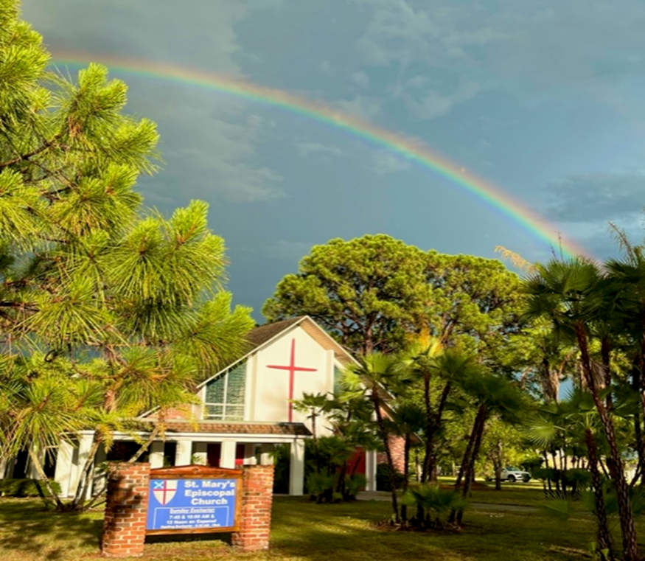

**St. Mary’s Episcopal Church**

1010 24th Avenue West, Palmetto, FL 34221

941-722-5292

Email – [stmaryspalmetto@verizon.net](mailto:stmaryspalmetto@verizon.net)

Website – stmaryspalmetto.com

**The Sunday Celebration of the Holy Eucharist**

**Epiphany 2**

**January 19, 2025**

**PARISH STAFF**

**The Rev. Glen Graczyk, Rector** [frgleng@gmail.com](mailto:frgleng@gmail.com) (727) 432-4014

**The Rev. William de la Torre, Hispanic Ministry (**813) 802-8617

**Rev. Cheri Ford, Assisting Priest** (941) 981-3195)

**Music Minister: Joyce Ives** (603) 236-1939

**Admin. Asst. Tina Clemen** [stmaryspalmetto@verizon.net](mailto:stmaryspalmetto@verizon.net) (941) 722-5292

**ST. MARY’S VESTRY**

**Senior Warden – Frank Grondahl** [ffgskg@msn.com](mailto:ffgskg@msn.com) **(**941) 900-1009

**Junior Warden** **– Bill Cooley** [dcool12839@gmail.com](mailto:dcool12839@gmail.com) (518) 796-2352, (518) 791-2774

**Treasurer**- **Lorraine Wood** [ljhwood53@gmail.com](mailto:ljhwood53@gmail.com) (941) 447-3570

**Beverly Hunt** [Huntb104@gmail.com](mailto:Huntb104@gmail.com) (941) 228-1888

**Nancy Valenti** [nancyval@hotmail.com](mailto:nancyval@hotmail.com) (941) 729-1824

**Peggy Brogan** [pegbrogan48@gmail.com](mailto:pegbrogan48@gmail.com) **(**941) 744-6429

**Lynda Priepot** [lyndajpriepot@yahoo.com](mailto:lyndajpriepot@yahoo.com) (941) 504-2505

All music printed in bulletin is under One License.net

**Prelude: *Peace and love and joy* …** J.S. Bach

**Call to Worship: *Emmanuel***

*Emmanuel, Emmanuel; His name is called Emmanuel.*

*God is with us, revealed in us; His name is called Emmanuel.*

**Processional Hymn: *Christ, whose glory fills the skies*** -#7

**The WORD OF GOD**

Stand

**Celebrant (C):** Blessed be God: Father, Son, and Holy Spirit.

**People (P):** *And blessed be God’s Reign, now and forever. Amen*

**Hymn of Praise:**

**07:45am** – P356 **BCP**

**10:00am** – ***Gloria – Mass of Creation*** – Buff music insert

**Collect of the day:**

**C:** My sisters and brothers the Lord be with you.

**P:** *And also, with you.*

**C:** Let us pray.

Almighty God, whose Son our Savior Jesus Christ is the light of the world: Grant that your people, illumined by your Word and Sacraments, may shine with the radiance of Christ’s glory, that he may be known, worshipped, and obeyed to the ends of the earth: through Jesus Christ our Lord, who with you and the Holy Spirit lives and reigns, one God, now and forever.

**P:** *Amen*

**The Lessons**

Sit

**First Reading: *Isaiah*** 62:1-5

**R:** The Word of the Lord.

**P:** *Thanks be to God.*

***Psalm*** 36The congregation will respond after the asterisk. (*)

Your love, O LORD, reaches to the heavens, *

*And your faithfulness to the clouds.*

Your righteousness is like the strong mountains, your justice like the great deep; *

*You save both man and beast, O LORD.*

How priceless is your love, O God! *

*Your people take refuge under the shadow of your wings.*

They feast upon the abundance of your house; *

*You give them drink from the river of your delights.*

For with you is the well of life, *

*And in your light we see light.*

Continue your loving-kindness to those who know you, *

*And your favor to those who are true of heart.*

**Second Reading:** ***1 Corinthians*** 12:1-11

**R:** The Word of the Lord.

**P:** *Thanks be to God.*

Stand

**Gospel Hymn: *Blessed Jesus, at thy word*** - #140 vs. 1 & 2

**C:** My sisters and brothers a reading from the Holy Gospel of our Lord Jesus Christ according to ***John***.

**P:** *Glory to you, Lord Christ.*

**Gospel: *John*** 2:1-11

**C:** The Gospel of the Lord.

**P:** *Praise to you Lord, Christ.*

**Gospel Hymn:** #440 vs. 3

Sit

**Homily:**

*Stand*

**Profession of Faith: *The Nicene Creed*** Page 358 **BCP**

**Prayers of the People:** Please respond: *Spirit of God, hear our prayer.*

**The Peace:**

*Sit*

**Announcements:**

**Offertory Sentence:** Through Christ let us continually offer to God the sacrifice of praise, that is, the fruit of lips that acknowledge God’s Name. But to do good and to distribute, forget not; for with such sacrifices God is well pleased ***Hebrews*** 13:15-16

**Offertory Song: *Come my way, my truth, my life*** - #487

**THE GREAT THANKSGIVING:**

*Stand*

**The Preface:**

**Sanctus:**

**07:45am** – recited

**10:00am – *Holy, Holy*** - ***Mass of Creation –*** Buff music insert.

**Eucharistic Prayer A** –

**Memorial Acclamation:**

**07:45am** – recited

**10:00am** – ***Mass of Creation – buff music insert.***

**Doxology and Great Amen**

**07:45am –** recited

**10:00am – *Amen* - *Mass of Creation*** Buff music insert

***The Lord’s Prayer:***  *Our Father …*

**Breaking of the Bread:**

**C:** [Alleluia.] Christ our Passover is sacrificed for us;

**P:** *Therefore, let us keep the feast. [Alleluia.]*

**Prayer for a Spiritual Communion:**

My Jesus, I believe that you are truly present in the Blessed Sacrament of the Altar. I love you above all things, and long for you in my soul. Since I cannot receive you in the Sacrament of your Body and Blood, come spiritually into my heart. Cleanse and strengthen me with your grace, Lord Jesus, and let me never be separated from you. May I live in you, and you in me, in this life and in the life to come. Amen

**Communion Song: *Immortal, Invisible, God only wise*** – #423

**Prayer After Communion:** page 366 **BCP**

**Blessing:** Please respond “Amen” after each of the biddings.

**Closing Hymn: *How wondrous and great*** – #532

**Dismissal**

**Prayer of Healing and Wellness:**

***Parishioners:***The Bustle’s, Kathryn Stevenson, Karen Moore, Priscilla Martin, Marilyn Wolter, Jodey Porter, Bill Gill, Bill Speer, Louise Silvanic, Lynda Priepot, Steve Ives, Barbara Renney, Mary Jane Daggett, Ora Mae James and Fr. Glen.

***Family and Friends:*** Brand Ramsey (family friend of The Reynolds), Charlotte (daughter of Holly Quillian), Robert Johnson (son of Lynda Priepot), Betsy Ramsey and Mary and Jack Hertenstein (friends of The Reynolds), Dick Stagner (brother in law of Louise Silvanic), Steve Gillespie (nephew of Gail Cascella), Nicola Moxey (daughter of Christine Pratley), Taryon Degon (granddaughter of Jan Ciancarelli), Carol Johnson’s sister, Christine Booth (Fr. Glen’s sister), Karen Perdue (Gail Cascella’s niece), Kevin-Ford family (family of The Ford’s), Paul Ciancarelli (Jan’s son), Art Sounia (friend of Doreen Colket) and Juliet Clarke (granddaughter of Pratley’s), Joe Fairchild (friend of the Cooley’s), Melanie Moran (friend of Christine) and Emily Ann Norris (family of Linney Reynolds), Marge Schrauth (friend of Fr. Glen), Dan Bryan (brother-in-law of Bob Cabnet), Maxwell Kappel (grandson of The Martin’s), Maxon McNeil (friend of the Shorts), Jayme and Jeremy (family of Cooley’s), and Kathy Harlow (sister of Doreen Colket), John Heath (friend of Jane Bryant), Ron Bernot (Neighbor of Dinny Sayre), Jordan Skeard (nephew of Alice and George Short), Rev. Jane Allen (Short’s priest in Newfoundland), Elleh Kearley (sister of George and Alice Short), George Silvanic (Louise’s grandson), Wally Skeard (brother in law to George & Alice Short), Wall, Elisa Hughes, Dr. Greg Gutowski (Priscilla Martin), Steve Harlow (brother-in-law of Doreen Colket), Charles (friend of Mindel De La Torre), Karen Fitzgerald (cousin of Doreen Colket), Beth Hunt (niece of Beverly Hunt), Dan Burkhart (neighbor of George & Alice Short), Evelyn Smith and daughter Michelle (friends of George & Alice Short).

***Prayers for Safety and Service****:*

Ben Richardson (son of Christine Pratley), Alexander Moxey (grandson of Christine), George Phillip Silvanic (Louise Silvanic’s grandson), Jody Cooley (son of Bill and Donna Cooley), and Logan Valenti (grandson of Nancy Valenti).

***January / February 2025***

|  |  |  |  |  |  |  |
| --- | --- | --- | --- | --- | --- | --- |
| **19**  **Worship Services**  **7:45am & 10:00am**  **12 Noon – Spanish**  **\*Annual Parish Meeting after 10:00am service** | **20**  **Fed’l Holiday**  **MLK Jr. Day**  **Banks & USPS Closed** | **21**  **Food Pantry**  **09:00 – 11:00 am**    **Vestry Meeting ** 2:00 pm** | **22**  **Healing Eucharist & Bible Study 09:30 am** | **23** | **24** | **25**  **Thrift Shop**  **09:00 – 12:30 pm**  **Café’ Rolle**  **09:00 – 11:00 am** |
| **26**  **Worship Services**  **7:45am & 10:00am**  **12 Noon – Spanish**  **William Gill** | **27** | **28**  **Food Pantry**  **09:00 – 11:00 am** | **29**  **Healing Eucharist & Bible Study 09:30 am**  **Steve Ives** | **30** | **31** | **1**  **Peggy Brogan** |