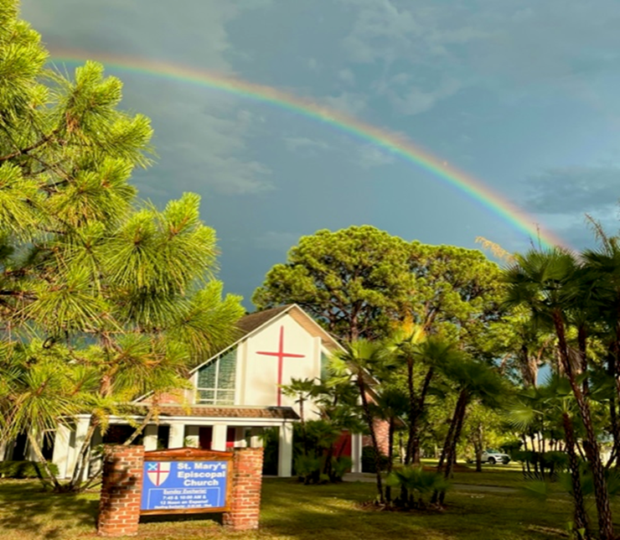

**St. Mary’s Episcopal Church**

1010 24th Avenue West, Palmetto, FL 34221

941-722-5292

Email – [stmaryspalmetto@verizon.net](mailto:stmaryspalmetto@verizon.net)

Website – stmaryspalmetto.com

**The Last Sunday after the Epiphany**

**March 02, 2025**

**PARISH STAFF**

**The Rev. Cheri Ford, Priest** [revcheri.stmaryspalmetto@gmail.com](mailto:revcheri.stmaryspalmetto@gmail.com) (906) 450-5718

**The Rev. William de la Torre, Hispanic Ministry (**813) 802-8617

**Music Minister: Joyce Ives** (603) 236-1939

**Admin. Asst. Tina Clemen** [stmaryspalmetto@verizon.net](mailto:stmaryspalmetto@verizon.net) (941) 722-5292

**ST. MARY’S VESTRY**

**Senior Warden – Frank Grondahl** [ffgskg@msn.com](mailto:ffgskg@msn.com) **(**941) 900-1009

**Junior Warden** **– Bill Cooley** [dcool12839@gmail.com](mailto:dcool12839@gmail.com) (518) 796-2352, (518) 791-2774

**Treasurer**- **Lorraine Wood** [ljhwood53@gmail.com](mailto:ljhwood53@gmail.com) (941) 447-3570

**Beverly Hunt** [Huntb104@gmail.com](mailto:Huntb104@gmail.com) (941) 228-1888

**Nancy Valenti** [nancyval@hotmail.com](mailto:nancyval@hotmail.com) (941) 729-1824

**Peggy Brogan** [pegbrogan48@gmail.com](mailto:pegbrogan48@gmail.com) **(**941) 744-6429

**Sue Cowhig** [jscowhig@sbcglobal.net](mailto:jscowhig@sbcglobal.net) (707) 980-3056

**Holly Quillian** [hollyqsaks@outlook.com](mailto:hollyqsaks@outlook.com) (941) 729-8325

All music printed in bulletin is under One License.net

**Prelude: “*Bagatelle” … Ludwig van Beethoven***

**Call to Worship: *Surely the presence of the Lord is in this place***

*Surely the presence of the Lord is in this place,*

*I can feel his mighty power and his grace.*

*I can hear the brush of angel’s wings, I see glory in each face;*

*Surely the presence of the Lord is in this place.*

**Processional Hymn: *Alleluia! Sing Jesus*** -#460

**The WORD OF GOD**

Stand

**Celebrant (C):** Blessed be God: Father, Son, and Holy Spirit.

**People (P):** *And blessed be God’s Reign, now and forever. Amen*

**Hymn of Praise:**

**07:45 am Pg 356 BCP**

**10:00 am – *Gloria S-280***

**Collect of the day:**

**C:** My sisters and brothers the Lord be with you.

**P:** *And also, with you.*

**C:** Let us pray.

O Lord, you have taught us that without love whatever we do is worth nothing: Send your Holy Spirit and pour into our hearts your greatest gift, which is love, the true bond of peace and of all virtue. Grant this for the sake of your only Son Jesus Christ, who lives and reigns with you and the Holy Spirit, one God, now and forever.

**P:** *Amen*

**The Lessons**

Sit

**First Reading: *Genesis*** 45:3-11, 15

**R:** The Word of the Lord.

**P:** *Thanks be to God.*

***Psalm* *37:***1-12, 41, 42The congregation will respond after the asterisk. (*)

Do not fret yourself because of evildoers *

*do not be jealous of those who do wrong.*

For they shall soon wither like the grass, *

*and like the green grass fade away.*

Put your trust in the LORD and do good; *

*dwell in the land and feed on its riches.*

Take delight in the LORD, *

*and he shall give you your heart’s desire.*

Commit your way to the LORD and put your trust in him, *

*and he will bring it to pass.*

He will make your righteousness as clear as the light *

*and your just dealing as the noonday.*

Be still before the LORD *

*and wait patiently for him.*

Do not fret yourself over the one who prospers, *

*the one who succeeds in evil schemes.*

Refrain from anger, leave rage alone: *

*do not fret yourself; it leads only to evil.*

For evildoers shall be cut off, *

*but those who wait upon the LORD shall possess the land.*

In a little while the wicked shall be no more; *

*you shall search out their place, but they will not be there.*

But the lowly shall possess the land: *

*they will delight in abundance of peace.*

But the deliverance of the righteous comes from the LORD; *

*he is their stronghold in time of trouble*.

The LORD will help them and rescue them: *

*he will rescue them from the wicked and deliver them, because they seek refuse in him.*

**Second Reading:** ***First Corinthians*** 15:35-38, 42-50

**R:** The Word of the Lord.

**P:** *Thanks be to God.*

Stand

**Gospel Hymn: *Christ upon the Mountain Peak*** #129 vs. 1, & 2

**C:** My sisters and brothers a reading from the Holy Gospel of our Lord Jesus Christ according to ***Luke***.

**P:** *Glory to you, Lord Christ.*

**Gospel: *Luke*** 6:27-38

**C:** The Gospel of the Lord.

**P:** *Praise to you Lord, Christ.*

**Gospel Hymn:** #129 vs. 3 & 4

Sit

**Homily:**

*Stand*

**Profession of Faith: *The* *Nicene Creed*** Page 358 **BCP**

**Prayers of the People:** Please respond: *God of love, hear our prayer.*

**The Peace:**

*Sit*

**Announcements:**

**Offertory Sentence:** Offer to God a sacrifice of thanksgiving and make good your vows to the Most High. ***Psalms*** 50:14

**Offering Hymn: *When morning gilds the skies*** - #427

**THE GREAT THANKSGIVING:**

*Stand*

**The Preface: *Mass of Creation***

**Sanctus: S129**

**Eucharistic Prayer: *Mass of Creation***

**Memorial Acclamation:**

**07:45 am –** Recited

**10:00 am - *Mass of Creation*** – Buff music insert

**Doxology and Great Amen**

**07:45 am –** Recited

**10:00 am - *Mass of Creation*** – Buff music insert

***The Lord’s Prayer:***  *Our Father …*

**Breaking of the Bread:**

**C:** [Alleluia.] Christ our Passover is sacrificed for us;

**P:** *Therefore, let us keep the feast. [Alleluia.]*

**Prayer for a Spiritual Communion:**

My Jesus, I believe that you are truly present in the Blessed Sacrament of the Altar. I love you above all things, and long for you in my soul. Since I cannot receive you in the Sacrament of your Body and Blood, come spiritually into my heart. Cleanse and strengthen me with your grace, Lord Jesus, and let me never be separated from you. May I live in you, and you in me, in this life and in the life to come. Amen

**Communion Hymn: *Break thou the bread of life*** – insert

**Prayer After Communion:** page 366 **BCP**

**Thanksgiving: *Sometimes* …** Henry Mancini

**Blessing:**

**Recessional Hymn: *Christ is made the sure foundation*** – #518

**Dismissal**